An Overview of Various Process Scheduling Algorithms
Brian Lockwood and Ryan Foster
{lockwobr,fosterrr}@uwec.edu

Abstract
By analyzing statistics of many well know process schedulers we will explore the pros and cons of several process scheduling algorithms. To do this we’ve produced ten random sample inputs. Each set of inputs contains one hundred processes with randomly generated bursts and arrival times. Randomly generated priorities, deadlines, and nice values are also generated for respective algorithms. The algorithms that we are going to look at are:
- Highest Response Ratio Next (HRN)
- Multilevel Feedback Queue System (MFQS)
- Real-Time Scheduling
  - Hard
  - Soft
- UNIX based

Introduction
We wrote four programs that simulate four different process schedulers. These programs take in a list of processes that have four arguments. The processes have a process identification number (PID), burst, CPU arrival time, priority, deadline, and Niceness.

Processes
The pseudo processes that the programs take in need certain pieces of information to run a given process. The processes need to have a PID (process identification number), burst (the time that the process needs to finish running), and the time that process arrives to the ready queue. This is the base input that all the algorithms need to run. HRN and MFQS need only this data. However, UNIX needs a niceness value and priority value. The default niceness value is 0. The niceness value will affect the priority of the process (this is discussed later). The priority value is used tell the processor what runtime queue it belongs too. RTS needs a Deadline value. This value is the time the process has to be finished by.

Highest Response Ratio Next
Highest Response Ratio Next (HRN) is a non-preemptive scheduling algorithm. This algorithm is centered around a response ratio that is based on your burst time and waiting time. Waiting time is the amount of time a process waits in the ready queue. This ratio for determining precedence is below. This algorithm will run the process with the highest ratio next.
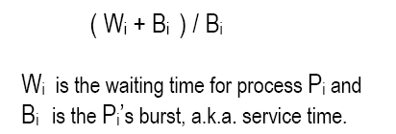

Real-Time Scheduling
Real-Time Scheduling (RTS) is a real-time scheduler. There are two kinds of the real-time schedulers: hard real-time, and soft real-time. A hard real-time system requires a process to complete a critical task in a guaranteed amount of time (or else the scheduler terminates). A soft real-time computing requires that a critical process receives priority over other processes; but in the case of a failure-to-reach-deadline situation in soft RT, the process aborts and other processes are allowed to run, often making necessary acknowledgments that a particular process failed.

Multilevel Feedback Queue System
Implementation
Multilevel Feedback Queue System (MFQS) has 3 to 5 ready queues. The last queue, which has least frequented CPU usage, is always first come, first serve (FCFS); and the remaining queues are round robin (RR). FCFS is a process scheduling algorithm of its own. FCFS puts the process in a queue and runs them in the order that the processes are pushed onto the queue. This is algorithm (FCFS) is performed only on the last queue. The processes in the last queue have attempted to finish their burst time in each higher-precedent queue, but have failed to finish and gotten pushed down into subsequent queues. After all attempts of finishing a process’ burst are exhausted, it is put in the bottom-most queue (which runs FCFS).
All runtime queues except the last, implement the round robin (RR) algorithm. In round robin a time quantum specifies how long each process in a queue is allowed to use the CPU. If a process finishes within the allotted time, the next process begins. However, if the process does not finish within the specified quantum, in common round robin implementations, the process is put at the end of the queue, behind all other processes. In the Multilevel Feedback Queue System, however, if a process does not finish its processing in the allotted time, it gets bumped to a queue with lower ‘priority’. In each subsequent queue of lower ‘priority’, the time quantum is doubled. The queues of lower ‘priority’, and longer time quanta, do not run as long as a queue of higher ‘priority’ is not empty. There are n-1 queues which run round robin. The n^{th} queue runs FCFS as mentioned earlier. FCFS can be a dangerous algorithm if not monitored carefully; processes have the capability of being starved in the last queue if some processes have a never-ending runtime.
To prevent process starvation, an “aging” procedure is performed on processes waiting in the FCFS queue. Each clock cycle, a waiting in the last queue is aged. If a certain user-specified age is reached by a process waiting in the last queue, it is bumped up to the next lowest queue (the queue with the next highest priority above the last queue).

Analysis

The graph below is a representation of 10 randomly sampled inputs of 100 processes running with various initial time quanta, age factor, and amount of queues. The average turnaround times are being compared among various time quanta, age factors, and amount of queues.

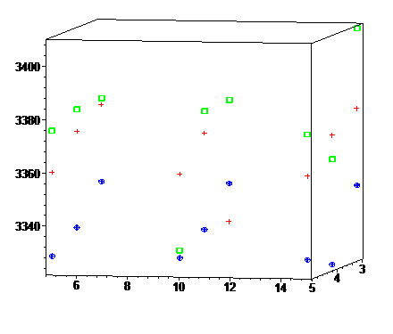
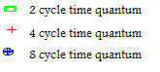

Fig 1.
For each time quanta in the graph above, the average turnaround time is show in cycles on the Z-axis. The x-axis, parallel to the page, represents the age limit for the processes to load up from the last queue. The y-axis, going into the page, represents the amount of queues used for the implementation of the MFQS algorithm.

It appears that with using the MFQS algorithm, a higher number of queues frequently results in a lower average turnaround time for processes. As aging goes up however, this trend is less congruent. It is notable that with the age factor set to 15, and time quanta set to either 2 or 8, the average turnaround time is at a minimum. However, strangely enough this result is not reproduced for the time quantum of 4 cycles. This anomaly is currently unaccounted for, and could be studied more in-depth in the future with a wider range of statistical process sampling.
The age factor seems to have an ambivalent effect on the result of average turnaround time. When examining the age axis (which is parallel to the page), each average turnaround time has little fluctuation for each time quantum (keeping the amount of queues is held constant).

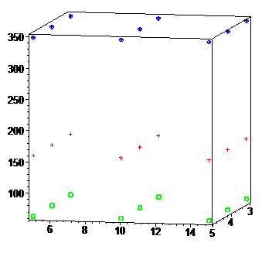
Fig 2.
The graph on the left represents the average waiting time for various implementations of the MFQS algorithm. The axes are labeled similarly as above; the average turnaround time is show in cycles on the Z-axis. The x-axis, parallel to the page, represents the age limit for the processes to load up from the last queue. The y-axis, going into the page, represents the amount of queues used

The graph above conveys the average waiting time for implementations of MFQS. Here it is apparent that varying neither the age-factor nor the amount of prioritized queues has any effect on the average waiting time. The lower the time quantum which is used however, is clearly proportional to a lower average waiting time.

UNIX-based System
The UNIX-based System scheduler operates very similarly to the MFQS algorithm. The UNIX scheduler also utilizes multiples queues. The UNIX scheduler however has a fixed amount of queues (3). For each of the three queues, a round robin method is implemented. The three queues too, are prioritized as for the Multilevel Feedback Queue System. The highest priority queue, which consists of priorities [0-30), consists of uninterruptible processes. The middle priority queue, which consists of priorities [30-60), holds interruptible processes. The lowest priority queue has priorities designated [60-90], which consists of processes which have the lowest priority, or user priorities.
It is only after the higher priority queues are empty that a subsequent queue can begin to run its round-robin based scheduler. A user-specified time quantum is used statically across each priority queue. Each priority queue can be pre-empted after a specified recalculation quantum. Upon each recalculation quantum, the priorities are recalculated as follows:

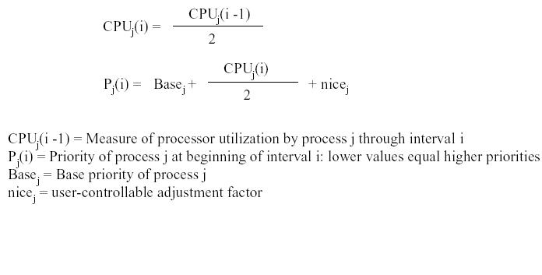
Explicitly, one can view the measure of processor utilization by a process as:
(burst – time remaining).

The UNIX scheduler has three queues. It uses a preemptive RR for the three queues. Preemptive priority RR is just like RR but the read queue is sorted by priority. Also if new process is added to the queue and has a higher priority than the process that is running in the CPU, then the process in the CPU gets preempted.

Conclusion
test
test
test
test
test
test
test
test
test
test
test
test
test
test
test
test
test
test
test
test
test
test
test
test

